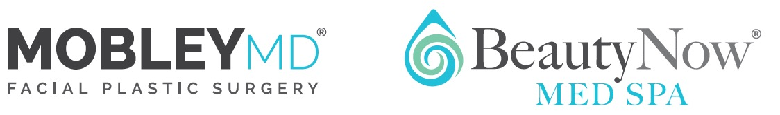


INFORMED CONSENT FOR SURGICAL OUTCOMES

ON-CALL POLICY

Dr. Mobley is in solo private practice. This arrangement ensures many benefits for patients, such as a very customized office surgical experience. Every effort is made to be available to patients as much as is humanly and reasonably possible but no one doctor could himself be available to every patient 24 hours a day, 365 days per year. Dr. Mobley maintains several on-call relationships with doctors in the valley. Dr. Mobley is also a member of St. Marks Hospital and a clinical adjunct Associate Professor of Surgery at the University of Utah Hospital.
If you were to experience a serious concern after business hours or on the weekend, you should first try contacting Dr. Mobley. In most cases, he will be able to assist you via his cell phone but if he is out of town and you need to be seen in person, it is very likely that one of the on-call doctors would be available to assist in your care. After that, your options would include going to the emergency rooms of St. Mark’s Hospital, or the University of Utah Hospital, all of which should have an otolaryngologist and/or a plastic/facial plastic surgeon on call who can provide proper emergency/urgent medical care. If your home is more than a few hours from Salt Lake City, you may wish to contact a local ENT surgeon or facial/plastic surgeon rather than traveling to Salt Lake City.
IN THE CASE OF A LIFE-THREATENING EMERGENCY, YOU SHOULD PROCEED DIRECTLY TO THE NEAREST EMERGENCY ROOM RATHER THAN TRYING TO CONTACT DR. MOBLEY OR ANY OF HIS ASSOCIATES AND THEREBY DELAYING TREATMENT.

With over a decade of experience, Dr. Mobley has found that true on-call emergencies are fortunately few and far between. The purpose of this policy is to inform you that every effort will be made to connect you with Dr. Mobley in the rare event of a true on-call emergency. If Dr. Mobley is unavailable, you should have confidence knowing that there are several different options for you to pursue, including seeking care in an emergency room. The chances of any one patient needing this care are quite small but in healthcare there is no such thing as zero risk, so we provide this information to you with full transparency.

I have read the above and understand the On-Call Policy.

Patient Name:

Guardian Name (if applicable):

Date:

Signature:

